Document Computer Language,
Commands As A Concept,
Project Summary

Author: Jan-Joost van Zon
Location: Oosterhout, The Netherlands
Date: June 21, 2008 – July 28, 2008

Goal
Work out everything regarding:

- Automatic execution order
- Parameters, input, output, throughput
- The implementation of commands as a concept

And their diagram expression.
So basically everything that has to do with execution.

Also, there will be looked at, to which extent this all can solve concurrency issues.

Originally, this project was set aside, because it was too hard and there was lots of other work to do. But in the project Diagram Expression for Execution Control a lot of the topics became clearer, so now it can be worked out more easily.

Because IO parameters and command IO are dependent on assignment, and assignment is dependent on the system interface, the topics about the system interface and assignment were also fully worked out.

Super-project
Document Computer Language

Time
June 21, 2008 – July 18, 2008 …
4 weeks …
<66 ¾> hours of work

Means
Execution Control should be involved in the story.
System commands are also involved, for reasons elaborated about in the brainstorm texts.
At first ignore that parameter notations may have discrepancies with automatic containment.

Products
At the beginning of the project, the amount of articles to produce or adapt was 43.

The following ~158 articles are to be produced or adapted:

Part A:

- Intermediate work: (3)

- Basic Diagram Elements

(add the wavy line)

- Normal Execution Order in a Diagram

(update it)

- Isolate Storage Principles

(has nothing to do with the project, but I want to do that.)

- System Objects: (38)

- System Object Introduction
- System Object in a Diagram
- Objects Floating Around
- Objects Floating Around in a Diagram
- Related Item
- Related Item in a Diagram
- Controlling a Related Object
- Controlling a Related Object in a Diagram
- Pointer To Pointer
- Pointer To Pointer in a Diagram
- Symbol
- Symbol in a Diagram
- Object Get & Set
- Object Get & Set in a Diagram
- Pointer To Pointer Get & Set
- Pointer To Pointer Get & Set in a Diagram
- Value Get & Set
- Value Get & Set in a Diagram
- New & Annul
- New & Annul in a Diagram
- Related Lists
- Related Lists in a Diagram
- Related List Item
- Related List Item in a Diagram
- Add
- Add in a Diagram
- Remove
- Remove in a Diagram
- Names of Related Items & Related Lists
- Names of Related Items & Related Lists in a Diagram
- Calling a System Command
- Calling a System Command in a Diagram
- Related Items & Related Lists Collections
- Related Items & Related Lists Collections in a Diagram
- Extending the System Interface
- Extending the System Interface in a Diagram
- System Object Summary
- System Object Summary in a Diagram

- Intermediate work: (3)

- Nothing
- Nothing in a Diagram
- Sub-Object

(adapt this article)

The definition of sub-object is not right anymore,
because I say in the Object Reference article,
that object references are no longer called sub-objects.

Assignment: (30)

(the notation for assignment is made simpler)
(command assignments the same as object assignments)
(extended with object reference assignments and alternative assignments)

- Assignment =
- Assignment in a Diagram
- Assignment in Text Code (not finished)
- Value Assignment v=
- Value Assignment in a Diagram
- Value Assignment in Text Code (not finished)
- Object Assignment o=
- Object Assignment in a Diagram
- Object Assignment in Text Code (not finished)
- Class Assignment c=
- Class Assignment in a Diagram
- Class Assignment in Text Code (not finished)
- Interface Assignment i=
- Interface Assignment in a Diagram
- Interface Assignment in Text Code (not finished)

- Object Reference Assignment =→
- Object Reference Assignment in a Diagram
- Object Reference Assignment in Text Code (not finished)
- Object Reference Object Assignment
- Object Reference Object Assignment in a Diagram
- Object Reference Object Assignment in Text Code o=→ (not finished)
- Object Reference Class Assignment
- Object Reference Class Assignment in a Diagram
- Object Reference Class Assignment in Text Code c=→ (not finished)
- Object Reference Interface Assignment
- Object Reference Interface Assignment in a Diagram
- Object Reference Interface Assignment in Text Code i=→ (not finished)

- Alternative Assignments
- Alternative Assignments in a Diagram
- Alternative Assignments in Text Code (not finished)

Currently working on

Basic Command Topics: (65)

> The story starts out new
> This is the new article list
> The original articles are still there, but will be used as a cross out list

> Perhaps give every topic a preliminary implementaton article

- General:

< These articles should explain more about creation behavior too. >

- Commands
(Introduction)
(Executable Object)
- Commands in a Diagram
- Commands Implementation (not finished)
- Command Definition
- Command Definition in a Diagram
- Command Call
- Command Call in a Diagram
- Command Reference
- Command Reference in a Diagram
- Clause
> A clause is always private, so it can not directly called from elsewhere, unless you hand out a reference to the clause.
- Clause in a Diagram
- Active Clause
- Active Clause in a Diagram
- Inactive Clause
- Inactive Clause in a Diagram
- Executions
- Executions in a Diagram
- Inactive Command
- Inactive Command in a Diagram
- Creation Behavior Of Command Calls
- Creation Behavior Of Command Calls in a Diagram
- Comparison to CPU-Like Call Instantiation

- One containing the other:

- Earlier articles, before making the split-up more thorough:

- Sub-Commands
- Sub-Commands in a Diagram
… Sub-Commands in a Command Definition
… Sub-Commands in a Command Reference
… Sub-Commands in a Command Call
… Sub-Commands in an Active Clause
… Sub-Commands in an Inactive Clause

- Command Calls in a Command Definition
- Command Calls in a Command Definition in a Diagram
- Command Calls in a Command Reference
- Command Calls in a Command Reference in a Diagram
- Command Calls in a Command Call
- Command Calls in a Command Call in a Diagram
- Command Calls in an Active Clause
- Command Calls in an Active Clause in a Diagram
- Command Calls in an Inactive Clause
- Command Calls in an Inactive Clause in a Diagram
- Active Clauses in a Command Definition
- Active Clauses in a Command Definition in a Diagram
- Active Clauses in a Command Reference
- Active Clauses in a Command Reference in a Diagram
- Active Clauses in a Command Call
- Active Clauses in a Command Call in a Diagram
- Active Clauses in an Active Clause
- Active Clauses in an Active Clause in a Diagram
- Active Clauses in an Inactive Clause
- Active Clauses in an Inactive Clause in a Diagram
- Parameters in a Command Definition
- Parameters in a Command Definition in a Diagram
- Parameters in a Command Reference
- Parameters in a Command Reference in a Diagram
- Parameters in a Command Call
- Parameters in a Command Call in a Diagram
- Parameters in an Active Clause
- Parameters in an Active Clause in a Diagram
- Parameters in an Inactive Clause
- Parameters in an Inactive Clause in a Diagram
- Private Objects in a Command Definition
- Private Objects in a Command Definition in a Diagram
- Private Objects in a Command Reference
- Private Objects in a Command Reference in a Diagram
- Private Objects in a Command Call
- Private Objects in a Command Call in a Diagram
- Private Objects in an Active Clause
- Private Objects in an Active Clause in a Diagram
- Private Objects in an Inactive Clause
- Private Objects in an Inactive Clause in a Diagram
- Inactive Clauses in a Command Definition
- Inactive Clauses in a Command Definition in a Diagram
- Inactive Clauses in a Command Reference
- Inactive Clauses in a Command Reference in a Diagram
- Inactive Clauses in a Command Call
- Inactive Clauses in a Command Call in a Diagram
- Inactive Clauses in an Active Clause
- Inactive Clauses in an Active Clause in a Diagram
- Inactive Clauses in an Inactive Clause
- Inactive Clauses in an Inactive Clause in a Diagram
- Command References in a Command Definition
- Command References in a Command Definition in a Diagram
- Command References in a Command Reference
- Command References in a Command Reference in a Diagram
- Command References in a Command Call
- Command References in a Command Call in a Diagram
- Command References in an Active Clause
- Command References in an Active Clause in a Diagram
- Command References in an Inactive Clause
- Command References in an Inactive Clause in a Diagram

- Commands’ object and class redirections:

- Command Definition Object
- Command Definition Object in a Diagram
- Command Definition Class
- Command Definition Class in a Diagram
- Command Reference Object
- Command Reference Object in a Diagram
- Command Reference Class
- Command Reference Class in a Diagram
- Command Call Object
- Command Call Object in a Diagram
- Command Call Class
- Command Call Class in a Diagram
- Active Clause Object
- Active Clause Object in a Diagram
- Active Clause Class
- Active Clause Class in a Diagram
- Inactive Clause Object
- Inactive Clause Object in a Diagram
- Inactive Clause Class
- Inactive Clause Class in a Diagram

- Miscellaneous topics:

- Recursion
- Recursion in a Diagram
- Commands & Executions
- Commands & Executions in a Diagram
- Parameters & Arguments
- Parameters & Arguments in a Diagram
- Target Command Definition
- Target Command Definition in a Diagram

For in the interface article group: (5)

- Command Definition Interface
- Command Reference Interface
- Command Call Interface
- Active Clause Interface
- Inactive Clause Interface

Influenced topics:

- Basic Diagram Elements

(use of object lines and class lines for commands is different now)

Implementation of System Commands:

You may need to add separate explanations about the implementation of the system commands.

Part B:

Assignment Related:

(these are currently brainstorm texts)

- Read-Write Direction
- Read-Write Direction in a Diagram
- It is not true, that you only Get an object to Set another object reference. You can also get an object to then access a sub-object of the object.
- Transfer of indirect values
- Transfer of indirect values in a Diagram
- Input / output not always values

- Parameters
- Parameters in a Diagram

- Parameter Types

> You have to consider commands and classes loosely coupled in the notation of parameter passings.

- In, Out, Thru & Downput Parameters
- In, Out, Thru & Downput Parameters in a Diagram
- Downput Parameter
- Downput Parameter in a Diagram
- In Parameter
- Out Parameter
- Thru Parameter
- By Value
- By Value in a Diagram
- By Reference
- By Reference in a Diagram
- Value In
- Value In in a Diagram
- Value Out
- Value Out in a Diagram
- Value Thru
- Value Thru in a Diagram
- Reference In
- Reference In in a Diagram
- Reference Out
- Reference Out in a Diagram
- Reference Thru
- Reference Thru in a Diagram
- Object Out
- Object Out in a Diagram
- Parameter Type Issues
- Parameter passing notations are implicit
- Can’t reference each parameter
- Parameters’ transfer of indirect values
- Legacy Parameter Concepts
- Required & Optional
- Required & Optional in a Diagram
- Variable Amount
- Variable Amount in a Diagram
- Return Values
- Return Values in a Diagram
- Miscellaneous Parameter Concepts
- Parameters For The Add Command
- Parameters For The Add Command in a Diagram
- Parameters For Attributes
- Parameters For Attributes in a Diagram

Influential concepts:

- Events
- Versioning

Advanced Command Topics:

- Automatic determination of parameter in / out / thru

(do start listing out topics in a general Flat & Structured interchange article)

- Command IO
- Command IO in a Diagram

(taken out of the automatic execution order section)
- Accessing parameters’ sub-objects
- Specific data unknown
- Parameters & IO
- Sub-commands’ IO

- Pre- & Postconditions

- Conditions
- Conditions in a Diagram

- User Commands

> If executions are only executed by parent executions, then what is the parent execution of the parent execution of the parent execution? Well, the upper parent command is actually comes from a human being. A person can execute a command definition.

Flat & Structured Interchange:

- Commands & Classes Loosely Coupled

Redo, making it a real relation between commands and objects.

Subdividing the commands from different site into different interfaces of an object, is a separate issue to address.

The use of object lines and class lines for commands has changed.

- Automatic Execution Order

(I am going to have to take a lot of these topics out from under automatic execution order. Because many things are just facilitating and handy for other stuff too. But it’s not priority nr. 1 to do that.)

- Parameters of calls directly tied together
- Parameters tied together
- Parameters tied to objects
- Outcome dependency

- Compared IO

Project steps
… Only then start writing the articles
The biggest issues now are:
- System interface:
- Symbols & pointers
Plan now:
- Create articles for each term
- Read over articles
- Reformulate articles
- Create diagram expression articles
- Cover details
Horribly much is involved.
The implementation of the system objects almost completely covers the code base.
It is essential for understanding the workings of the new computer language.
The functional description of the system objects is essential for understanding many of the basic concepts and principles, such as assignment, concepts and static members.
- Assigning:
- Pointer to something
- Direct target
- Final target

Currently working on
- Commands:
- Isolate version of plan (before cutting up brainstorm texts)
- Command is an object
- Creation Behavior of Command Calls
- Work out article
- Wrap up brainstorm about more CPU-like
- Work out diagram expression article too
- Make already made articles more compliant with the creation behavior of command calls and more simple
> Not many adaptations were required.
- Continue with the other articles
- Wrote exactly one article now
And in what order to explain those things.
- Split up in sub-projects:
- Clarify command as a concept
- Work out system objects articles
- Work out assignment articles
- Work out basic command articles A
- Work out basic command articles B
- Work out parameter articles
- Work out advanced command articles
- Update class articles
You have to explain that an object has a class (that you can’t change, unless you convert the object, creating a new object) and an object reference / related object also has a class, that you can change, but not while another class’s object is assigned.
- Finally:
- Update the article Flat & Structured Interchange
- Update the articles Coding Principles and Coding Concepts

Basic Command Details
- Everything should be based on commands are objects straight away.
- I have to work out everything except:
- Try to cover everything you can without talking about parameters
- Automatic Execution Order
- Automatically determining what’s in, out or thru
- Every aspect of what turns an object into a command, must get a separate article.
- The primary aspects of what turn an object into a command should be the first few articles.
- In the first couple of brainstorm sections, I go over this material too quickly. The first story covers a ton of aspects, that should each get an article.
- Things work different for definitions than they do for calls.
- I think I should just sum up a ton of terms,
contemplate them one by one,
get any situation clarified
and then see how to better / further structure the story.
- You have to consider for each command concept, that even though a command has a few more rules to obey to compared to objects, you have to be able to break those rules, and only generate a warning, or you won’t be able to switch a symbol from being an object to a command and back.
> Calls are created briefly, but definitions are created permanently.

Material

Sub-Commands
A command definition contains a collection of other commands to execute.
The collection is sorted by the order in which these sub-commands will execute.

A command can be called from another command. After the called command completes the process returns to the calling command, which will then continue its execution.

Inside a command, usually just more commands are invoked.

There are only a few commands that do something other than call other commands. Those special commands perform a machine instruction: an operation that is executed by the CPU, the central processing unit of the computer. On top of those special commands, a few basic commands are created, to for instance control the flow of a program, making the next command to call dependent on a condition.

But basically, a command just calls more commands.

Active Clause
I keep being confused.
Anything you define, you define in a definition.
So how can you give an active clause arbitrary contents?
Because the active clause is part of the definition it is put in.
But what if you have sub-clauses that are all active?
Then they are all part of the definition closest up the hierarchy.

More Ideas
< Whereas a class determines the command of an object, a command definition does not add any commands to another command. You just can’t call commands out of a command. >

Sub-Objects in a Command Reference
same as in a command definition?

Other Ideas
When machine instructions are invoked in the new computer language as calls to new computer language commands, that invoke the instruction, then a string of such machine instructions has a real overhead around it. Therefore, pure stretches of assembly commands calls should be packed in a clause, that gets a binaral that is the exact machine code, compiled as a stretch of binary, instead of separate ‘symbol’ commands. That should take care of the overhead, when writing deep-core assembly stuff.

Have I even considered what commands and classes loosely coupled means in the notation of command calls upon objects? I think I have only considered command definitions in classes, not command calls upon objects…
If a parameter is a command’s object, then parameter passing notation has to also display object command definition calling. So the parameter type notation is incomplete.
Does that only apply to reference parameters?

A command reference should be a pointer to a pointer to a command?

Done

Clarify Command As A Concept Details
- Go through all ideas you can find
- Organize brainstorm items
- Reformulate brainstorm texts, determining how things will be
- In, out, thru, down
- Reconsider
- Integrate old text into new text
- Reformulate the introduction
- Reformulate the Parameter Passing Type Details
- Make the parameter passing specific sections a more complete description, taking over texts from the introduction.
- Reformulate the Issues sections
- Automatic Execution Order
- Reformulate
- Cross out remaining brainstorms
- Regroup information
- Postpone concurrency resolution
- Make it a future project
- System interface
- Remaining topics
- Read over some material:
- Read over the execution control articles
> Was not that influential anymore.
- Read over brainstorm texts.
3h
~X Revise the list of articles
- Version the brainstorm texts, before cutting it up.
- Change order of documentation:
- More into the order in which you really read it.
- It’s annoying a have to jump around the documentation all the time
- Drop Diagram and Text expression right next to conceptual explanation
- Mix Coding Principles and Concepts
- I constantly change my mind about implementing something as a principle or as a concept.
- It is also annoying to have some assignment topics on one end of the documentation, and other assignment topics at the other end of the documentation
- Add ‘Implementation’ section to each concept.
- Change the documentation titles
(articles have moved to another documentation section)
- Group together Concept and Diagram versions.
- Per concept
- For groups of concepts
- Try to make the file names nice again.
- Better numbering of articles.
~X Summary of what the code base will consist of / which coding concepts are principles.
- Flat & Structure Interchange spread around the documentation too.
- But do put a summary in Fundamental Principles
- Diagram expression requires some extra topics:
- Basic diagram elements
- Diagrams as a concept
- Automatic containment (is also a diagram expression topic.)

System Interface Article Details
Details:

- I think I want to add references to the articles of the members of a system interface to the articles about for instance Related Item, Related List and Related List Item.
> Anything in these brainstorm texts is probably worth mentioning somehwere in the documentation, because if I have trouble with it now, it is probably worth explaining to somebody else, that wiill be dealing with the material.
- Functional aspects:
- Related list item extension procedures
- I didn’t determine the notation for the list item extension procedures yet.
- After a lot of drawings, the final drawing was the final notation of it
- 2008-07-20 07
- 2008-07-21 01
> Draw it out differently: give related list items a reference to a list, and give the list a reference to a system procedure.
- 2008-07-21 02
- 2008-07-21 03
- 2008-07-21 04
- 2008-07-21 05
Notation of extending a system command of a related list item.
- 2008-07-21 06
Notation of all extensible parts shown in the system interface of a related list.
- Don’t draw out parameter passing
> In this part of the documentation it is not yet worked out how to pass parameters, so you can’t really draw out parameter passing yet. Do mention that in the documentation, that parameter passing is not drawn out, because it parameter passing will only be introduced later.
- This just covers the notation, not the way the system objects are tied together internally.
- This alters the following articles:
- Related Lists
Add the related list item command extension objects to the sum-up of system interface members.
- Related List Item
mainly add a small part about how the implementation is not covered there.
- Extending the System Interface
I have to say that the Item commands and Gets and Set in the system interface of the related list are not commands, but objects, with references to the extension procedures, because the Item Gets and Sets and commands in the related list are not executable commands, but configurations of the commands of the related list items, and a configuration is stored by an object.
- Extending the System Interface in a Diagram
Show how the extension of an item elements of the system interface of related list looks.
- System Interface Summary
Add the related list item command extension objects to the system interface of a related list.
- System Interface Summary in a Diagram
Show the diagram with all the extension objects of a related list.
- Extension procedure part of parent:
- But the extension procedures are not defined by the list object. The extension procedures are defined by the parent object.
This counts for related items too. A related item’s extension procedures are defined by the parent object.
Extension procedures need to be normal commands, not system commands.
> It is just more practical to make the extension procedures part of the parent object. Only a normal computer language object can define commands, that have all the possibilities of computer language. You can’t really change objects like related items or related lists, because they are system objects. Those system objects can only be extended, not changed.
- Object references inherently part of parent:
> Theoretically it does not matter whether extension procedures are defined by for instance inside a related item or inside the parent object of a related item. A related item is part of the parent object anyway, as opposed to the actual object the related item refers to. The reference to the object is part of the parent object. The object is not.
> Objects referred to by a parent object are not part of the parent object, but the references to the object are part of the parent object. Objects such as a related list or a related item are system objects that are inherently part of the parent object. Only the objects referred to are not part of the parent.
- System objects
- Rename the whole concept of System Interface to System Objects.
- Adapt the articles:
- System Objects
- Objects Floating Around
- Related Item
- Controlling a Related Object
- Pointer to Pointer
- Symbol
- Object Get & Set
- Pointer To Pointer Get & Set
- Value Get & Set
- New & Annul
- Related List
- Related List Item
- Add
- Remove
- Extending The System Interface
- Summary
- I need to define the term system object somewhere, as a term mainly used for objects such as related items, related lists and related list items.
- The system objects and commands are basic objects and commands implemented by the code base. The system objects are not normal objects. They are special deep-core system objects, that control relations between normal objects.
In the first layer of the code base, the system objects and system commands are not comparable to normal objects and commands in the new computer language. But the code base gets reprogrammed using te new computer language itself and then the system objects and commands are implemented the same as any other object or command. But they are still the system objects, that have the special position of controlling the other objects.
- You have to make clear, that the notation of the system objects and the implementation of system objects are totally separate things.
- System objects such as Object . ID are also system objects: they are the related objects: an object reference embedded inside a related item or related list item. Perhaps I should put the term related object in the system interface summary, in the diagram that shows all the terms.
- Explain somewhere, why a system object is often called a system interface
The system object really represents an object. So usually you will see a system object as being the object itself, while the system object really only controls a pointer to the actual object. So when you see the members of target object of a system object, showing the actual members of the system object, is like showing the system interface of a related object. That’s why instead of calling it a system object, it is often callled a system interface of a related object.
- Writing style:
- It is stupid, that I can’t see the complete system interface of a related item in the article Related Item in a Diagram. I only get redirected to other articles for that. The reason I did that, was because I only explain the system commands in other articles. But I still want an overview of it, even though I haven’t explained anything about it yet.
> Related List Item
- Something sucks about the summary article, because not everything is mentioned in it.
- In the member articles (e.g. Object Get & Set) refer to the articles about the system objects to which the members apply.
- A parent object should be able to define multiple extension procedures for the same kind of extension, for the same related item or related list, because when you let an object support a concept, the concept can add another extension to a the system command. So an extension procedure is not a single-cast event.
- Access control
A lot of things about the system interface needs to be access controlled. Access control will only be worked out in the future. You do however have to mention it in the documentation everywhere, where access control has to be applied. Refer to the access control documentation, but also immediately mention the needed access control’s physical effect.
Do put in the preliminary access control documentation, that you need to consider everything about access control in the system interface.
- Notation of call to a system command.
- Consider related item’s ID In Parent…
> I’m thinking right now (2008-07-21 19:16), this is part of relation synchronization.
> No (2008-07-24 19:27). It is part of the concept of having a list of Related Items inside the parent object.
- System objects / code base / concepts,
2008-07-24
System Objects covers almost the complete code base
This means, that for a complete overview, you would still need the Related Items and Related Lists system objects. But the usage of system objects may not require knowledge of the objects Related Items and Related Lists. However, in order to author concepts, you have to have those collections available. You’ll also need to be able to extract an Attributes collection as well. And a methods collection.
It is worth considering completing the story like that.
But it already has been a lot of work, and I might want to just get on with it.
- A related item and related list have a name. The name should be a system member, because it needs to be used by concepts.
- Add members to summaries and articles related item, related list:
- ID In Parent
- Name
- Add something about the collections Related Items and Related Lists to the summary.
- I don’t have any references to the main article. I don’t redirect from the main article to the sub-articles.
- Reflection:
Het is irritant om eerst de conceptuele uitleg te doen en daarna de diagrammen.
Als je aan de diagrammen werkt, dan is het net of je geen stap vooruit komt, want je was eigenlijk al klaar met de conceptuele uitleg.
Maar in het geval van de System Interface artikelen kon het niet anders, want de conceptuele uitleg is heel erg brainstormsgewijs tot stand gekomen, daarna opgesplitst in onderwerpen en stukjes tekst bij een onderwerp neergeplakt, en daaran de tekst geherformuleerd. Daarna moesten de diagramnotaties nog.
De Assignment artikelen zullen waarschijnlijk minder langdradig zijn, omdat als je bij het eind van het verhaal komt, je ook echt klaar bent.

Assignment Details
- Old set of articles organization:

- Assignment
- Assignment in a Diagram
/ Value Assignment
- Value Assignment in a Diagram
/ Object Assignment
- Object Assignment in a Diagram
- Command Definition Assignment
- Command Definition Assignment in a Diagram
- Class Assignment
- Class Assignment in a Diagram
- Interface Assignment
- Interface Assignment in a Diagram
- Command Interface Assignment
- Command Interface Assignment in a Diagram

The set of articles will change

At first there was only direct assignment of:

- Value
- Object
- Class
- Interface
- Command Definition
- Command Interface

Commands will become a concept, automatically making Command Definition the same as Class, and Command Interface the same as Interface. That leaves us:

- Value
- Object
- Class
- Interface

You do need to mention it in the articles when an assignment is also synonym for a command assignment.

Pointer assignment adds more types of assignment. Object, Class and Interface assignment each get two types of assignment:

- Object assignment:
Assigning the object as the target
- Object reference assignment:
Assinging the related object as the target

Any alternative form of assignment can be accomplished by calling system commands and assignment commands.

This creates a different set of articles:

- Assignment =
- Assignment in a Diagram
- Assignment in Text Code (not finished)
- Value Assignment v=
- Value Assignment in a Diagram
- Value Assignment in Text Code (not finished)
- Object Assignment o=
- Object Assignment in a Diagram
- Object Assignment in Text Code (not finished)
- Class Assignment c=
- Class Assignment in a Diagram
- Class Assignment in Text Code (not finished)
- Interface Assignment i=
- Interface Assignment in a Diagram
- Interface Assignment in Text Code (not finished)

- Object Reference Assignment =→
- Object Reference Assignment in a Diagram
- Object Reference Assignment in Text Code (not finished)
- Object Reference Object Assignment
- Object Reference Object Assignment in a Diagram
- Object Reference Object Assignment in Text Code o=→ (not finished)
- Object Reference Class Assignment
- Object Reference Class Assignment in a Diagram
- Object Reference Class Assignment in Text Code c=→ (not finished)
- Object Reference Interface Assignment
- Object Reference Interface Assignment in a Diagram
- Object Reference Interface Assignment in Text Code i=→ (not finished)

- Alternative Assignments
- Alternative Assignments in a Diagram
- Alternative Assignments in Text Code (not finished)

You have to take the following details into consideration:

> You can assign a class to a sub-object, but you can also assign a class to an object. When and how do you do which?
> I have only described assigning it to a sub-object.
> Perhaps you first assign a class to a sub-object and then create the sub-object . You can’t change the class of an object after it is created.
You have to mention this in class assignment.
> You always access an object through an object reference, and an object reference is always part of the object reference’s parent. So you are always accessing an object through another object.
> What if you want to assign a pointer to a class as the class of a symbol, instead of assigning a class to a symbol?
> I guess normally you’ll just assign the class of a symbol to another symbol. If that class is a pointer to a pointer to a class, you’re assigning the pointer to the pointer to the other symbol. Assigning the target class may need to be another type of assignment.
> In that case, you need to leave out the term target in the normal assignments, and add a new set of possible assignments: target object assignment, target class assignment, etcetera.
- Alternative assignments, not target assignments
What if you want to assign the Target Class as the class target of an object reference. I could imagine: c=c→→
You could do the same for interfaces.
But you could do the following anyway:
A c=→ B . Target Class
The diagram is worked out on paper.
Object reference assignment is mandatory.
But target object reference assignment is not. Target object reference assignment is less common, and possible in an alternative way. Target object reference assignment also leads to thinking about assigning other types of targets and it would clother the language with a bunch of alternative notations for things that are less common, for which a general notation can be used.
> Commands and objects more the same
Class and definition assignment are the same in that case,
and then there is only one type of interface assignment.
> Calls are created briefly, but definitions are created permanently.
- How does that influence the different types of assignment?
- It means definitions could get object lines anyway, and calls can not.
- Articles to change:
- Object assignment
- Object reference object assignment
- Class assignment
(rephrase small parts)
- Object reference class assignment
(rephrase small parts)
- Incorporate:
To make direct conversion between a command and an object
possible without any loss of structure, a call must be
able to have an object line
In that case the rule is: when a call symbol has an object line,
the object line behaves as a class line.
But it does require a warning to be generated.
- Explain unsimplified notations of assignment
I should display the notation of an assignment calling upon system commands.
I didn’t know how to do it before, but now most is known about the system interface, I do know how to express it.
Object assignment:
(Picture -1)
B . Object . Set ( A . Object . Get )
(Picture 0)
B . Object . Set ( A . Object . Get . a Value )
(Simplified) (because in an assignment you do not need to show the words Get and Set, but s general assignment does not exist)
B . Object = A . Object
(Picture 2 ½)
o= ( B , A )
B o= A
(Picture 3)
B o= A
Object reference object assignment:
B . Other Related Item . Set ( A . This )
B . Other Related Item . Set = A . This
B o=→ A
- Articles to adapt:
- Assignment
- Assignment in a Diagram
- Assignment in Text Code
- Object Reference Assignment
- Object Reference Assignment in a Diagram
- Object Reference Assignment in Text Code
- Wrap it up with more references to other articles:
- In the main article refer to all the sub-articles.
- In all the sub-articles refer to the main article.
- Maybe references to the articles target objects, target classes and target interfaces
> Only referenced target objects in the article Alternative Assignments.
- In Target Object Reference Assignment and Object Reference Assignment refer to the article Automatic Containment for an explanation on imaginary reference lines.
- Put all references to other articles in the see also list
- Class and interface assignment:
If an object does not have a class,
then the object itself should be assigned as a class.
If an object does not have an interface,
then the object itself should be assigned as an interface

Reassess my priorities
But then, most of all, I need to start focussing on the things I really know, and not on the things I don’t know yet.

I think I have to shove everything I don’t know how to solve yet to the end of the documentation.
And I have to shove everything I already know to earlier in the documentation.

But crap, some of the things I don’t know how to solve yet were mandatory, weren’t they? Yes, some. But automatic execution order isn’t. And automatic object formation isn’t. And even more isn’t.

Everything optional, but fantastic, that I don’t know how to solve yet, has to be put in a separate section. It has to be dumped under ‘Other Topics’.

Why am I being so hard on myself?
Everything takes so much time, so why aren’t I doing the things that take the least time first?
I think this is because I’m being subconsciously drawn to a challenge.

Ideas

Commands as a concept
Keep in mind, that in earlier articles it was explained, that a command is a separate entity, as opposed to being part of a specific class.

But there is more to the behavior of a command, compared to a normal object.

The command definition can also contain a set of related objects. Those are the parameters of the command. They are just input, output, throughput or downput. This input, output, throughput and downput is passed on to the sub-commands, that are given outward references to these items (the parameters of the sub-commands are pointers to pointers that way). Some parameters may become required, so that you have to fill them in, or have to use them as output.

A command definition is a permanently created object. It has to be created, because it needs to store what becomes the input and output of its sub-commands. For that, the sub-commands are also created objects. They have a fixed logical residence inside the command definition, even though their definition is totally elsewhere.

Sub-commands are not executed by the definition itself. A command definition is dormant, statically present and permanently created. But a call is different. A call refers to its definition, and takes over everything from the definition, but a call is only created right before it executes and destroyed short after it is done.

Each call represents an individual command object, but a new command object is created each time the call is executed. The input of a call is set right before the command is executed. The output of the command is read right after the command is executed.
A new command object is created on each call to the command. Then the input is set. After the output has been read (which means: written to other objects) the whole command object is erased again.

The parameters are not really a list of objects passed to the call anymore. The call is an object, that has a set of object references in it, that are individually set.

All of this behavior is implemented as the Command concept. The Command concept can be supported by any object, upon which the object becomes a command.

The code base, however, in some basic form needs to support an object’s ability to execute.

The order in which the sub-commands execute can be manually set, but the technique of automatic execution order makes is possible to have the order automatically determined. Either way, the order of the sub-commands is stored inside the command definition.

A command has added behavior, compared to a normal object:

- It executes
- It contains a collection of sub-commands to execute
- A new command-object is created on each call to the procedure and the command-object is destroyed soon after the call.
- Input is written only right before the call.
- Output read only right after the call.

For the rest objects and commands are identical.

The added behavior of commands is implemented as the Command concept. When an object supports the Command concept, it automatically becomes a command. The code base only needs to support an object’s ability to execute in some basic form. But most of the fuctionality for commands is programmed within the new computer language itself. The code base only supplies the basic need to facilitate it.

For a command to execute, the sub-commands need to execute in the right order. The sub-commands again execute sub-commands. This going by the commands recursively probably needs to be present in the code base. The outer commands are machine instructions, which will also be called by the code base.

A command actually is an object, with some special properties: it executes, it contains calls to other commands, and the calls are executed in a certain order, part of which can be automatically determined.

All you need to do is assign the input parameters, ‘run’ the object, and assign the output to other objects.

For an object to have a reference to a command, you have to be able to define a relation between a command and an object. This is only possible, if a command is an object.
If you want to do that, you have to implement commands as a concept.

A command itself can also contain related command references, which are then considered parameters of the command.

Ideas
Commands,

Zo uit de losse pols verzin ik nu, dat een command een object is, waarvan de procedure in de constructor zit.

JJ

Classes & commands loosely coupled as relations between commands and objects
Parameters are the essential connection between commands and objects. If I can use a line merge in bidirectional relations between classes, does that mean that a line merge between a command parameter’s class line and a class command’s definition line should be considered a bidirectional relation between a class and a command? Should that be viewed more like a relationship, than anything else?

When a command definition gets an object with a class, this creates a relation between the command and the class definition. This means, that the class definition also gets a reference back to the command.

It looks like, when you turn a command into an executable object, without any additional effort automatically establishes the interchangability between class commands and command parameters. I didn’t expect that. If two seemingly independent concepts confirm eachother, I must be on the right track.

For objects of the class, this means, that they copy all methods of the class.
If the method changes, this changes the class configuration. The change in class configuration must then be ventilated through to all the objects of the class.
I haven’t accounted for that yet. The same effect is there for just data of objects: if the class configuration changes, the objects should change also.
Gee… you should be versioning. Objects do not change, because they link to a specific version of the class.
However when creating a command, and giving it a relation to a class, I guess I do want the command to be ventilated through to the objects? Or will I just forget about that?
Gee, the commands inside an object are no longer imaginary references. They are real ones now.
I guess, that only if you link to the development version, changes are ventilated through from the classes to the objects.

But command as a concept, as a way to establish interchangability between class commands and command parameters, also needs to subdivise the class commands into interfaces: one for each module commands are defined in.
How that is established by command as a concept is yet to be determined.

Automatic Containment for Relations is still a problem. Line merges for relations between commands and objects may have the same problem. I didn’t account for that earlier. A good example of this problem is yet to be drawn out.

Giving the issues in this section a place
Issues about casts need to be moved to the article Events. Also move changes to classes or commands to the article Events, as a primary example for the application of events.

Classes & commands loosely coupled needs to be adapted.

You can postpone explaining commands till later, explaining it first and foremost in terms of relations between commands and normal objects.

An object's references to its commands are not imaginary.

Subdividing the commands from different site into different interfaces of an object, is a separate issue to address.

Still ignore, that also for relations between objects and commands the diagram notation has discrepancies with the diagram notation of automatic containment.

Downput
Next to the terms input, output and throughput, the term downput will be introduced. Downput is intermediate data as a helper of a process, that will eventually produce output. Temporary variables, local variables. They are all downput. Actually, in the method-call structure, a method in which output data is disposed, this output as become downput.

The term downput is good, because it is only passed down into sub-commands. And it is dropped after the parent command is done (dropped down). It is ‘put down’ / rejected after the execution. Or put down / to put something down, that you had in your hand.

Read-Write Direction As A Connection
Formerly, the direction of input and output was indicated with an access mark on a reference line. But this created ambiguity with the indication of reference targets. Read-write direction is something so basic in computer language, that it deserves a separate line type. From now on, value direction will be indicated by a wavy line.

This is actually a good symbol for it, because it looks like a less direct connection than the other line types and it is a less direct connection. In fact, the two symbols aren’t connected at all. The wavy line looks like a less direction connection, because the complete length of the line, curves and everything, is much longer than a straight line. A wavy line also indicates heat, or activity, more than the other line types. Value direction is an action.

Read-write direction, input-output direction and value direction are synonymous terms.

A value line might not necessarily indicate yielding over the value of the object on one end of the line to the object on the other end of the line. It may be yielding over values between sub-objects. So it’s not synonym to a value assignment call.

When values are yielded over between sub-objects, then this is drawn out with a wavy line. A direct read and write is always drawn out as an assignment call. An assignment call almost looks the same as a value line, but now a diamond is there in the middle of the line. This is to distinguish direct reads and writes from indirect reads and writes.

Sometimes the command itself does not read or write from a parameter, but the parameter is passed to a sub-command, that reads or writes from the object. This yields over the in-out-thru properties of the parameter. This does give the parameter an indication of value direction, just no assignment is visible in the definition of the command. The assignments are done by a sub-command.

It is not clear yet if it is best to also use value direction to indicate addition, removal, creation and annulment of objects.

Input, output, throughput, downput

Introduction
Input, output and throughput are parameter passing types.
They are shortened to In, Out and Thru.
When a command’s parameter is In, it means that the command reads values from the parameter. When a command’s parameter is Out, it means that the command writes values to the parameter. When a command’s parameter is Thru, it means, that the command reads values and writes values to the parameter. Throughput functions as both input and output at the same time.

When a command disposes objects after it is done, then those objects are called downput. Downput may have been input for sub-commands, or it could have been output of sub-commands. To the parent command, though, it is downput. Downput parameters will not be further considered here, because they do not have anything to do with parameter passing.

Input values are written to the command right before the call. Output values are read right after the call.

In that case the parameters are passed by value: the value of one object is copied to the parameter of the command to call. And after the call, the values of the output parameters are copied to other objects. These kinds of input and output parameters are called Value In and Value Out and Value Thru.

Value In:
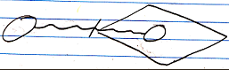

Value Out:


Value Thru:
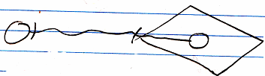

A read of an output parameter is always accompanied by a write to another object. A write to an input parameter is always preceded by a read from another object. A read operation is always accompanied by a write operation. A value is read from one object, only to be written to another object.

Next to passing a parameter by value, you can also pass a parameter by reference. For instance: instead of copying a value to an input parameter, you give the command a reference to an object outside the command.

Reference parameter:

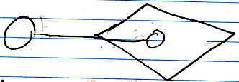

The called command can then read out of the object, that it was given a reference to. In that case it is called a Reference In parameter.

Reference In parameter:

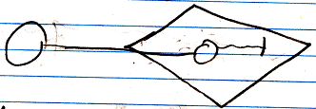

When a command is passed a reference to an object, and the command writes to the parameter, it is called a Reference Out parameter.

Reference Out parameter:

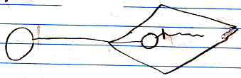

Next to Reference In and Reference Out, there is also Reference Thru, which means, that the command both reads and writes to the object passed to it.

Reference Thru parameter:

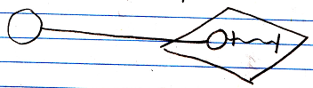

When a command call has an outward reference to an object, this does make the object a parameter, but this does not determine yet whether it is input, output or throughput. The in and out in this case refer to whether values are written or read to the object reference. A reference parameter is always sort of like input, though: the parent command passes the object to the sub-command, so the parent inputs something into the sub command. Therefore it can also be called Reference Outward, Value In and Reference Outward, Value Out But those names are too long. The distinction between Reference In and Reference Out is about whether values are read or written to the object passed to the sub-command.

The other way around is also possible: the sub-command passes a reference to an object to the parent command. The parent command refers to an object in the sub-command.

Reference Inward parameter:

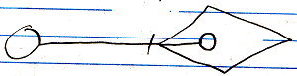

This is a Reference Inward parameter, as opposed to a Reference Outward parameter. The sub-command writes to the output object. The long name of this type of parameter passing is Reference Inward, Value Out.

Reference Inward, Value Out:

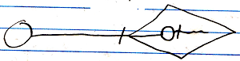

The sub-command can also read from the output object, but this doesn’t have anything to do with the parameter passing between parent- and sub-commands.

Reference Inward, Value In:

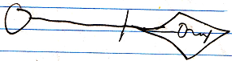

Reference Inward, Value Thru:

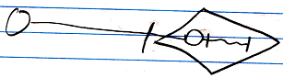

Because Reference Inward, Value Out is only relevant for the parent’s reading values from an output object, it is shortened to Object Out.

Object Out:

The assignments, that come with parameter passing are always done by the parent command. Whether it is Reference Inward, Reference Outward, or values, the assignments that come with parameter passing are always done by the parent command.

By Value, Reference Outward and Reference Inward are the different reference situations a parameter can have. But this tells us nothing about whether a parameter is input, output or throughput. What determines, whether it is in, out or thru is whether values are written to the parameter or read from the parameter.

So the long names of the different parameter passing types are:

- Value In
- Value Out
- Value Thru
- Reference Outward, Value In
- Reference Outward, Value Out
- Reference Outward, Value Thru
- Reference Inward, Value Out

Reference Inward, Value In and Reference Inward, Value Thru are not relevant. The Reference Inward parameter can be read from by the sub-command, but that it’s just not relevant to parameter passing between a sub-command and a parent command.

It is important to keep understanding that there are three elements to parameter passing:

- Values read or written
- Parameter is a reference outward
- Parameter is referenced from the outside

To understand how the different parameter passings came about, it is important to keep those three aspects in mind.

Here is a list of the parameter passings, with their short names, and their diagram expression:

- Value In

- Value Out

- Value Thru

- Reference In

- Reference Out

- Reference Thru

- Object Out

The reason why it is important to keep understanding the three aspects of parameter passing, is that Rerefence parameters, even though they can be In, Out or Thru, are always input in a way, because it is a reference passed from the parent command to the sub-command.

Value In and Value Out means reading and writing done by de caller. Reference In and Reference Out means reading and writing done by the called command. In both cases In does mean, that the called command uses something, and Out means, that the called command returns something.

Parameter Passing Type Details

By Value
Passing a parameter by value means, that the input or output is copied to or from the parameter object.

Parameters passed by value are really only useful for smaller amounts of data, that might be changed, but you don’t want the change to affect the original object. For an object, that only stores one value and that’s it, is is easy to just copy the value. For more complex objects, the question is, to what depth you are going to clone it. The cloning depth may be dependent on the parameter usage inside the command. Please only use passing a parameter by value for simple objects.

By value should only be used for simple object types with a binary value stored in it, or at most simpler objects, cloned to a certain depth. You should not use by value for complex object types.

Please don’t use passing a parameter by value for complex objects and expect no operation to affect the original object, because the deeper objects of it might not be cloned. The object may be passed to sub-commands, that will affect the original sub-objects. I will not elaborate on all the difficult situations that it may produce.

If you want to pass more complex objects to a command, you do it by reference. If you would pass more complex objects to a command by value, expecting no operation to affect the original object, this would make the various passing by value situations too complex, which is way beyond the goal of parameter passing by value.

Perhaps for that reason, no references to original objects will be cloned for by value parameters. Only values of sub-objects will be cloned.

In parameter passing by value, the parameter object and the object, that is passed the value to or from, are not referring to eachother at all.

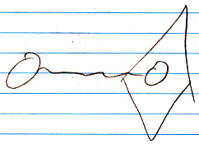

A value assignment performs a yield over of value.

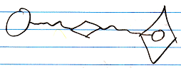

A value assignment does have an invisible reference to the parameter, but you won’t see it in the diagram, because an assignment is something so basic, that the notation of it is kept very basic.

The complicated notation:

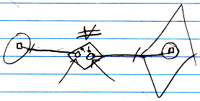

(the arrows are pointing to the references invisible earlier)

But this still does not tie the source and target symbols together.

By Reference
Next to passing a parameter by value, you can also pass a parameter by reference. For instance: instead of copying a value to an input parameter, you give the command a reference to an object outside the command.

Reference parameter:

When a command call has an outward reference to an object, this does make the object a parameter, but this does not determine yet whether it is input, output or throughput. The in and out in this case refer to whether values are written or read to the object reference. A reference parameter is always sort of like input, though: the parent command passes the object to the sub-command, so the parent inputs something into the sub command.

An object symbol (a circle) is always a pointer to an object, not a specific object.
So a reference parameter is a pointer to an object reference, not a pointer to a specific object.
So the parameter points to another pointer. The target pointer determines the eventual object pointed at.
The notation of a parameter as a pointer to a pointer, though, may become an implicit expression of just an object assignment.

In earlier programming languages one use of by reference was used to be able to pass large objects to a procedure. Another use was to be able to let the procedure have multiple return values, because in other programming languages a procedure can really only have one return value. In the new computer language, multiple return values is accomplished by having multiple Object Out parameters. So you do not need Reference Out parameters for that anymore.

Value In
A Value In parameter passes a value from an object to the parameter of a command. A Value In parameter is an object inside the command call, that is created right before the command is invoked, and a value from another object is then assigned to the parameter, before the command is run.

The command can manipulate the Value In parameter without affecting the original object.

A Value In parameter works best for a simple object, that stores a single value, but might also work for more complex objects, with more than just a single value, but that will require specifying a cloning depth, and comes with all sorts of downsides. See By Value.

A diagram of a command call with a Value In parameter:

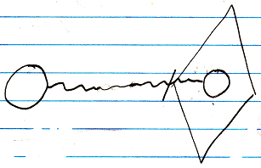

Or:

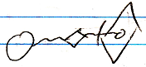

A diagram of a command definition with a Value In parameter:

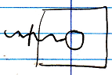

Or:

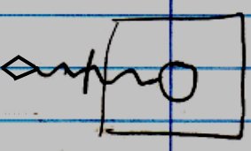

Value Out
A Value Out is a value produced by a command, that is yielded over to another object after the call is done. A Value Out output parameter is an object inside the command call, that is created right before the command is invoked. The parameter is written to by the command or by one of its sub-commands. The value of the output parameter is copied right after the call, assigning the value to another object.

Output values are parameters, that are not assigned before the call, but only read from after the call.

A Value Out parameter works best for a simple object, that stores a single value. But it might also work for more complex objects, with more than just a single value, but that will require specifying a cloning depth, and comes with all sorts of downsides. See By Value.

Command call with a Value Out parameter:

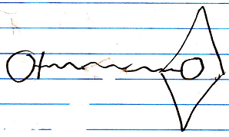

Or:

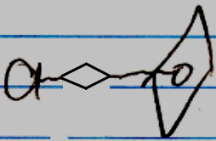

A command definition with a Value Out parameter:

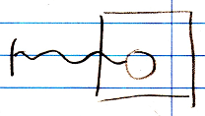

Or:

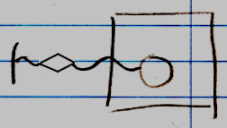

Value Thru
Throughput by value is when a by value parameter is first written to, then changed by the command, and then the value of the parameter is read from again, and assigned to the original object.

A Value Thru parameter works best for a simple object, that stores a single value, but might also work for more complex objects, with more than just a single value, but that will require specifying a cloning depth, and comes with all sorts of downsides. See By Value.

Command call with a Value Thru parameter.

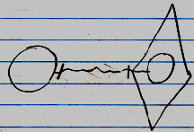

Or:

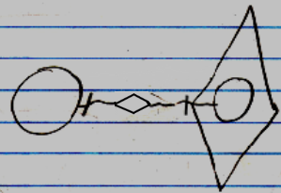

In theory, the value could first come from one object, and after the call be written to another object. But that’s not regularly what a Value Thru parameter is used for.

Command definition with a Value Thru parameter:

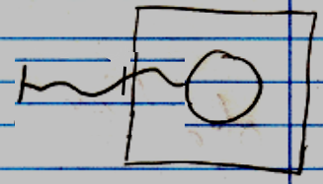

Or:

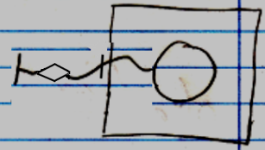

Reference In
A Reference In parameter can be used to assign a reference to a complex object as the input of the command.

Because a Reference In parameter is input, the called command can only read out of the object, that it was given a reference to.

Command call with a Reference In parameter:

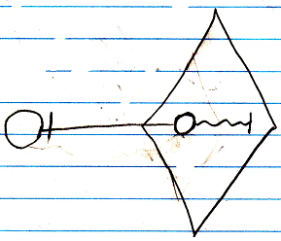

Or:

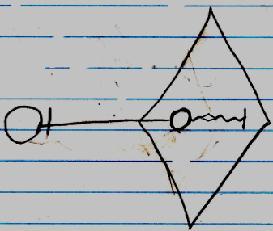

Command definition with a Reference In parameter:

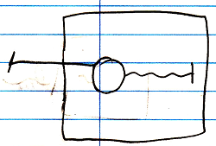

Or:

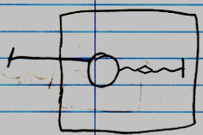

Reference Out
A Reference Out parameter can be used to assign a reference to a complex object to which a command writes output.

Because a Reference Out parameter is output, the called command can only write to the object, that it was given a reference to.

Command call with a Reference Out parameter:

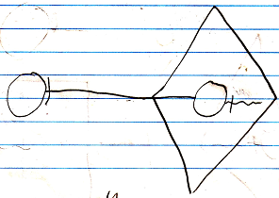

Or:

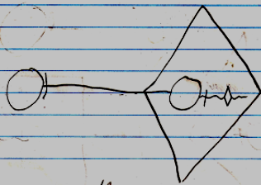

Command definition with a Reference Out parameter:

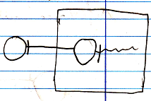

Or:

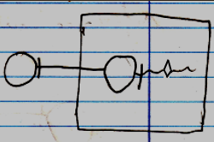

In a sense, a Reference Out parameter is actually throughput.
When output is alteration of an existing object, it could be considered throughput, even though there is only written to the object, and nothing is read from the object, it is still an object passed through the command.

A by reference parameter can not change the target object of the parameter or overwrite the target symbol of the reference parameter with a new object. Returning a new object or another existing object is reserved for the Object Out parameter.

Reference Thru
A Reference Thru parameter can be used to assign a reference to a complex object, from which input is read and output is written to.

A Reference Thru parameter is a pointer to something outside the command. The object pointed to both read from and written to.

Command call with a Reference Thru parameter.

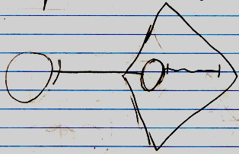

Or

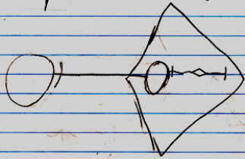

Command definition with a Reference Thru parameter.

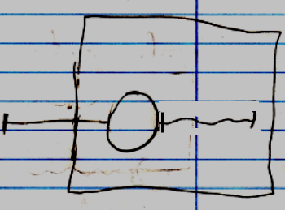

Or:

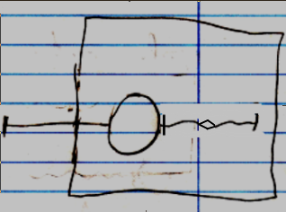

Object Out
An Object Out parameter is an object that resides inside the command. The Object Out may be a new object, or redirect to an existing object. Anyway, the command determines which object will be output. The produced object will be referenced from outside the command.

Unlike parameters passed by reference, an Object Out parameter is referred to. This is an exclusive aspect of the Object Out parameter passing type.

A diagram of a command call with an Object Out parameter:

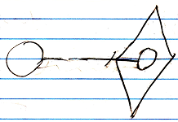

A diagram of a command definition with an Object Out parameter:

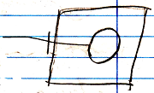

Unlike By Reference and By Value parameters, there are no three variations for parameters referred to. The reason ‘Object’ parameter passing does not have three variations, like the Value and Reference parameter passings, is that the command’s reading and writing values to the object is irrelevant to the parameter passing. Object Out does not have anything to do with whether the command call reads or writes from the object it outputs. That is irrelevant to the parameter passing.

A reference to an Object Out parameter causes an implicit run of the command, because a command can not return anything unless it is run. A reference to an Object Out parameter copies the target object of the parameter. It can’t permanently refer directly to the parameter, because nothing really exists inside the call unless the call is running.

Issues

Parameter Passing Notations Are Implicit
A reference parameter is assigned an object.

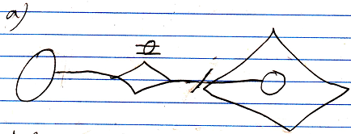

The assignment of an object can also be replaced with the redirection of an object.

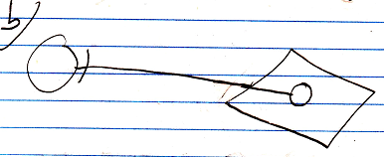

The target symbol is not the object itself, but an object reference. The parameter is a reference to an object reference. This makes the parameter a pointer to a pointer.

An object assignment, and a pointer to a pointer are not completely interchangable, but it is close to it.

Reference parameters could be made pointers to pointers, like in the notation, but the notation may also just be regarded an implicit notation of an object assignment.

A reference to an Object Out parameter is also an implicit notation for an object assignment from the parameter to a referrer. So that would nicely fit the two together: parameter references are also an implicit notation for object assignments.

The notations of value transmission for Reference parameters is also just an abstract expression:

It does not display which specific values are read or what the read value is copied to. It does however express the type of parameter passing.
It is an abstract display, not an implicit display.
< 2008-07-06 Any connection to or from a parameter is not really a statically present connection; it is an assignment, that is executed by the parent command on demand. >

Can’t reference each parameter
You can’t just reference each parameter. You can only reference a parameter when it is Object Out.

If a parameter is for instance Reference Thru, it can only point to something, but you can’t refer to a Reference Thru parameter. You can only give it a reference.

The caller can not redirect the Object Out parameter. The call itself may be able to redirect the Object Out parameter, but not to something outside the call, because the call is only aware of what’s reachable inside the call. This actually counts for objects as well. So the following situation is not possible:

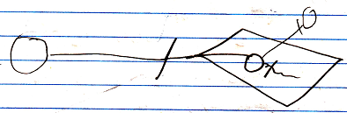

If the caller wants all the object symbols to represent the same object, it should do it for instance like this:

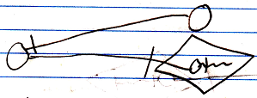

Transfer of indirect values
Something is input, output or throughput when values are read from it or written to it. But it does not need to be the value of one object being written to another object. It can also be values of sub-objects that are yielded over from one object to another. In that case, the parent object is considered input or output parameters, even though only the values of its sub-objects are used.

For By Value parameters an indirect value transfer means, that the input or output object is cloned to a certain containment depth, whereas a direct value transfer means, that only the direct value of the input or output object is copied.

For By Reference parameters, indirect value transfer means, that values are read and written from sub-objects of the reference parameter. Direct value transfer of By Reference parameters means, that only the direct value of the input or output object is read or written.

For an Object Out parameter, the type of value transfer does not matter, so it also does not matter whether there are direct value transfers or indirect value transfers.

When it is direct value transfer, an assignment call is shown in the diagram.

The above displays a Reference In parameter inside the call, whose direct value is used.

If it is indirect value transfers, then the diagram does not show an assignment call.

The above displays a command that uses values from the sub-objects of the Reference In parameter.

Because it is valuable parameter passing information, whether only the direct value of an object is accessed or also values of sub-objects, you can mention this in the name of the parameter passing type, for instance:

- Direct Value In
- Indirect Reference Out

This adds another aspect to the parameter passing types. This gives the parameter passing types thee aspects:

- In / Out / Thru (value direction)
- By Value / By Reference / Object Out (reference situation)
- Direct / Indirect (value usage)

Input / output not always values
Output is not always the assignment of a value, though. Output can also be the creation of an object, or addition of objects to a list. Output can also be assigning Nothing to an object reference, or removing objects from a list. It can also be the assignment of an object to an object reference.

Creation, addition, annulment, removal and object assignment are considered indirect value transfers. Ofcourse it is not really a value transfer, but it is output. Creation, addition, annulment, removal and object assignment only applies to output. So creation, addition, annulment, removal and object assignment specifically applies to Indirect Reference Out parameters.

However, input can also be merely accessing a sub-object to go to the next object. So input is also not always value transmission. That non-value transmission applies to Indirect Reference In parameters.

All in all, non-value transmissions apply to By Reference parameters only.

Parameters of calls directly tied together
In other programming languages, sub-commands do not directly read or write to eachother’s parameters. Parameters are only read or written by the parent command.

However, in the new computer language, parameters of sub-commands can be tied together directly.

One parameter type can only be tied to a parameter with specific other parameter type.

A Value In parameter can be only be tied to a Value Out parameter:

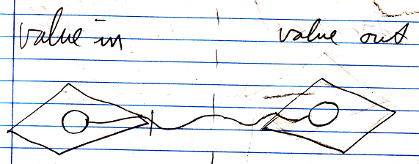

A Value Out parameter can only be tied to a Value In parameter:

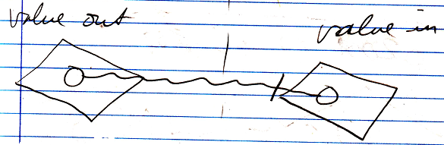

A Value Thru parameter can not be tied to another parameter:

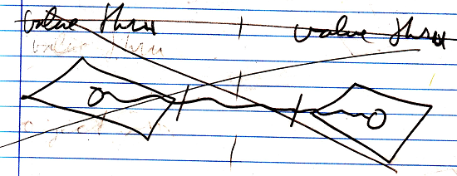

This is because it creates a circularity in which one parameter writes its values to the other, and the other parameter writes its value to the first parameter. It is just an unlogical circular situation.

A Reference In parameter can only be tied to an Object Out parameter:

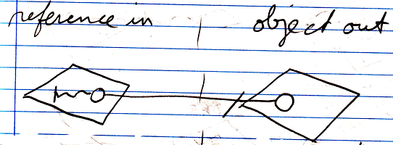

A Reference Out parameter can only be tied to an Object Out parameter.

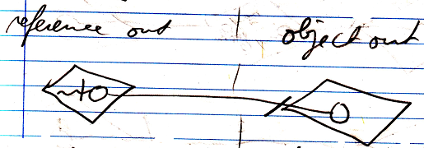

A Reference Thru parameter can only be tied to an Object Out parameter:

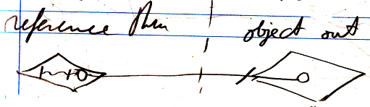

An Object Out parameter can be tied to a Reference In, Reference Out or Reference Thru parameter. In short an Object Out parameter can only be tied to a Reference parameter:

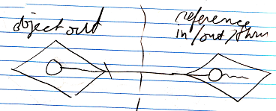

So to summarize it:

Only Value In parameters and Value Out parameters can be tied together:

Only Object Out and Reference parameters can be tied together:

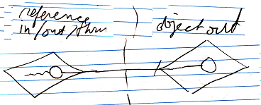

However, these direct connections between parameters is an implicit notation of reads and writes executed by the parent.

A direct value transfer:

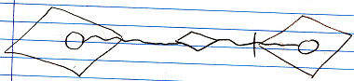

Is indeed already the explicit notation of it: the value of one parameter is assigned as the value of the other parameter.

An indirect value transfer:

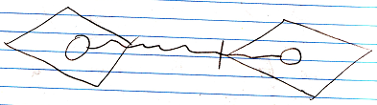

is in fact an implicit notation of a cloning operation performed by the parent. For indirect value transfers between By Value parameters, you might indicate the cloning depth:



The explicit notation of the Clone call:

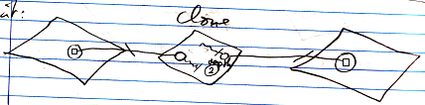

The command definitions with an indirect by value parameter, with a cloning depth indicated might look like this:

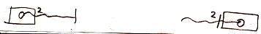

Looking at the explicit notation of the Clone call above, because the By Value parameters are referenced by the Clone operation, this sort of makes the by value parameters:

- Reference Inward, Value In
- Reference Inward, Value Out

However, this is not the way you want to look at it when programming. This is just what happens under the surface.

For object transfers between Object Out parameters and Reference parameters, the implicit notation is:

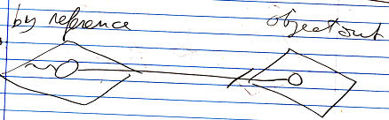

However, this direct connection between parameters is an implicit notation of an object assignment executed by the parent:

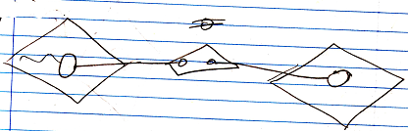

So the connection from the By Reference parameter to the Object Out parameter isn’t really a reference to a reference; it is an object assignment.

Because the Reference and Object Out parameters are referenced by the object assignment, this sort of makes the Reference and Object Out parameters:

- Reference Inward, Object In
- Reference Inward, Object Out

However, this is not the way you want to look at it when programming. This is just what happens under the surface.

The object assignment does not require the parent command to have a direct reference to the object. The object assignment can just refer to the object symbols. In text code ths may look like this:

A ( O o= B ( ) . O )

Command A is called, and its Reference In parameter O is assigned the output O of the command B. So no temporary variable is needed to first pick up the output of B and then assign it as input of command A.

Tying parameters together directly states a direct dependency. No direct reference to the parameter objects are required inside the parent command.

Next to making sub-command directly dependent on eachother like that,
input output can also be between a sub-commands parameter and a sub-object of the parent command. This does not create a direct dependency between sub-commands, but it does create an indirect dependency.

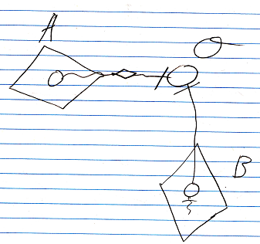

The parameter of command A is a Value Out parameter that writes to object O. The parameter of command B is a Reference Out parameter that connects to object O. The parameters of command A and command B are not directly tied to eachother, but they do indirectly related to eachother. This will be further elaborated in Automatic Execution Order.

Further parameter passing stereotyping
Comtemplations about further thru parameter passing stereotyping will be postponed.

The thru parameter passing type can be further split up in affected, used & affected, transformed, transformed same value, used & affected & transformed and used & affected & transformed same value.

<…>

Furthermore, thru can be either affected, used & affected or transformed or both. Affected is considered throughput, even though nothing is read from it, because the object is still passed through the command.

This gives us the following number of parameter passing situations:

- Value In
- Object In
- Reference In
- Value Out
- Object Out
- Reference Out
- Value Thru
- Value Thru, Affected
Value Thru, Affected does not make sense. You’d give a parameter an initial value, that does not get used, but will be overwritten. Value In is a better choice in that case.
- Value Thru, Transformed
- Value Thru, Used & Affected
- Value Thru, Used & Affected & Transformed
- Object Thru
- Object Thru, Affected
- Object Thru, Transformed
~ Object Thru, Transformed Same Value
- Object Thru, Used & Affected
- Object Thru, Used & Affected & Transformed
- Reference Thru
- Reference Thru, Affected
- Reference Thru, Transformed
~ Reference Thru, Transformed Same Value
- Reference Thru, Used & Affected
- Reference Thru, Used & Affected & Transformed

< When throughput it is affected and used, values are read and written from it to manipulate or coming out of other objects. When throughput is transformed, the values written to the throughput object were derived from values first read from the throughput object. >

Brainstorm
Do I really need to stereotype this many subtile variations? Isn’t the fact that it is thru enough to tie everything together?
This whole section in, out, thru is getting out of hand.
It was supposed to be simple. It wasn’t even there at first.
I have to simplify the story, keeping the split up in affected, used, transformed and ‘same value’ a detail
Then I need to work out the subjects under the assumption, that you only need to be concerned with in, out and thru.

Same Value
< Perhaps when it is the exact same variable that’s read and written, this should be stereotyped in a different way as well. It is transformed, but then specific values are both used and affected. Transformed where one part of the object is used, to affect another part of the object, is also transformation, but less rigorous, so perhaps you do need some sort of stereotyping for that. >

Throughput variations
< combinations:

not affected, not used, not transformed
-
not affected, not used, too transformed
transformed
not affected, too used, not transformed
used
> in, not thru
not affected, too used, too transformed
used & transformed
too affected, not used, not transformed
affected
too affected, not used, too transformed
affected & transformed
too affected, too used, not transformed
affected & used
too affected, too used, too transformed
affected & used & transformed

< only used is actually input, not throughput. >

The combinations, that are left, then:

affected
affected & used
transformed
used & transformed
affected & transformed
affected & used & transformed

Value Thru, affected
Does not make sense. You’d give a parameter an initial value, that does not get used, but will be overwritten.

Automatically determining what’s in, out or thru
The terms input, output, throughput and downput were discussed earlier. Here it is discussed how to automatically determine whether a parameter is in, out, through or downput.

Input, output and throughput has to do with value assignment, but also reference-assignment and other types of assignment, and also other machine instructions that perform a read-write operation.

Not only directly contained parameters are input, output or throughput. When sub-objects of a parameter are used, the sub-objects become input, output and throughput of the command. So the configuration of direct parameters does not determine at all what exactly is input, output or throughput. The usage of things determines it.

To automatically determine, whether a parameter is input, output or throughput, you should not only only look at the assignments executed by the command itself. Parameters, or sub-objects of parameters, are also passed to other commands. Whether something is input, output or throughput is equally dependent on whether it is input, output or throughput of a sub-command. If something is throughput for command A, and command A is called by command B, this automatically makes it throughput of command B. (This, unless it is command B’s downput.)

A rigorous way to automatically determine whether something is input, output or throughput, would be to traverse the whole structure of command calls. The assignments are the leaves of that structure (or any other form of read-write machine instruction is also a leave of this structure). Whether something’s input, output of throughput is derived from these assignments and machine instructions. You could encounter circularities traversing the call structure. So this would require circularity handling.

Whether something is input, output of throughput only changes when the command definition of a sub-command changes. So instead of traversing the whole command call structure to determine whether something is in, out or thru, you also could cast a change to all callers of the command, and their callers, and their callers, upon which the callers adapt their in-out-thru configuration accordingly. This creates a huge event cast. This needs to happen with events, and all dependencies should register themselves inside what they are dependent on.

This makes it possible, that you get very wide casts for a small change in the system. In a well monitored and regulated system this should be workable. Events will create this extreme activity, but that’s just an aspect of this new system. Computer systems will be extremely active, but this is solved by regulating input and output and quota-limits in space and time.

Any way it is done, you have to store inside a command, whether a parameter is input, output or throughput, whether it is automatically deteremined or not. Just like the execution order of sub-commands it is stored inside a command. You have to store whether something’s input, output or throughput, because otherwise, you have to redetermine it too many times using a complicated procedure.

Each command defines what is its input, output or throughput, and a new command can part take over the input, output, throughput configuration from its sub-commands.
However, when a definition of a command changes, a huge cast to all its callers and their callers, and their callers is executed.
Even this big event cast can be prevented. The answer is versioning. When you use versioning, a called command never changes. Only when command A decides to link to a newer version of command B, command A’s input, output, throughput configuration may change. If command B changes, command A keeps linking to the old version of command B. So the dependencies of command A do not change, and keep pointing to an old version of command A.
Only when programming a new version of a system, you can decide to possibly link to a new version of things. A version of a system, that is in production, keeps pointing to unchanging versions of their dependencies.
A question for versioning is: when will a version of a command be created? On every change? Or will there be key moments at which an author publishes the new version of the command. These are issues for Versioning, which falls under the Editing & Authoring concepts.
Versioning of commands can prevent huge casts of changes to input, output or throughput configuration, or at least limit it in size. Only when defining a new call, you have to look at the called command to see if this changes the in, out, thru configuration of the currently edited parent command definition.

Giving the issues in this section a place
The ideas about versioning need to be moved to the article Versioning.
The ideas about event casts should be moved to the article Events.
You should only refer to those articles, even when the articles are not not finished.

The rest is all part of automatically determing in-out-thru.

Automatic Execution Order
The first thought was, that the execution order of sub-commands could be automatically determined, based connection between parameters and objects, and whether parameter is In, Out or Thru and By Reference, By Value or Object Out. But this is not true.

Parameters tied together
When the parameters of two commands are directly tied together, it is not hard to determine the order in which to execute the commands. Parameters can only be directly tied together to eachother in a limited number of ways, so that makes it quite easy. One parameters is output, that is used as input for another command. A consultation of a command requires the command to run. The sub-commands have a direct dependency on eachother and a command requires its dependencies to run first.

< Pictures >

Parameters tied to objects
However, parameters can also be tied to sub-objects of the parent command.

< Picture >

If parameters of different commands are tied to the same object, and they are all input parameters, then the execution order of the sub-commands does not matter.
But if one of them is an output parameter, then it is a question whether the input parameter wants to use the changed value or the original value of the object. So in that case the order should be manually indicated.

< Pictures >

Outcome dependency
If a reading sub-command is dependent on the outcome of a writing sub-command, then you have to manually indicate the execution order, so that the writing command runs before the reading command. The indication of execution order in that case is sort of like indicating an outcome dependency. If you want the original value, you can indicate the execution order, drawing out, that the reading command should run first, which is like a negative statement of outcome dependency.

Outcome dependency is exchangable with execution order.

Multiple things may be dependent on the outcome of a command, which means that the writing command might have multiple next-command indications. That’s right. The dependencies could all run in parallel. From this dependency can be derived, that some things can be run in parallel, and some things have to run in a serial order.

Accessing parameters’ sub-objects
An object inside the parent command has sub-objects. From the parameter you can’t tell whether the object itself is written or an object 10 levels deep is written.

< Picture >

With reference parameters, changes and consults can be at any depth. Any object indirectly links to any other object in the world, so passing an object as a parameter makes basically any other object around the world accessible to the command. So basically anything could be changed by a command.

That used to be one argument in the claim, that automatic execution order is impossible, but help is on the way…

Specific data unknown
Another argument against automatic execution order is, that from a command definition, you still don’t know what specific data will be processed. This is because the parameters of the command are not yet filled in. A command definition does not have any objects assigned to the parameters yet. So it is not clear what exact data will be processed. Command definitions only indicate what types of object can be connected to the command, but not what specific objects are connected to the command. You only know what specific data is processed when a command has specific object connections. A command only has specific object connections when it actually runs. But even though, what a command will change seems pretty volatile, there are possibilities for predictions about what a command will change. Things considering eachother’s changings once a command actually runs, is a concurrency topic, that will be covered in Concurrency Resolution, but not in Automatic Execution Order.

Parameters & IO
Input and output are not the parameters, but what specifically is read or written from the parameters. The input and output of a command are not the parameters passed to it, but any piece of data used by the command. You just can’t see from the parameter itself exactly what is changed.

In theory there's no telling what a command may read or write, but in practice the amount of things read and written are limited. You can list out what a command reads and changes.

Here follows a textual definition of a parameter, and of the input and output; three entirely different things.

Parameter:

Reference Thru Document As Graphics . Document

Input:

Document . Points . Item [ * ] . X
Document . Points . Item [ * ] . Y

Output:

Document . Lines . Item [ 0 .. * ] . Point A . X
Document . Lines . Item [ 0 .. * ] . Point A . Y
Document . Lines . Item [ 0 .. * ] . Point B . X
Document . Lines . Item [ 0 .. * ] . Point B . Y

There must be a limitation in the expression of what is accessed. Perhaps if only Document's existance is being checked, this might be indicated. But to a certain extend the expression of what exactly is accessed should be limited. Not the entire inner workings of a command are visible from its input and output. For instance, in the input / output expression you will not be seeing what sub-commands are called.

What is written and read by a command are actually pre- and post-conditions of the command.

Only when you are editing a command, the pre- and postconditions of the command have to be determined. The pre- and postcoditions do not change once you’ve published, versioned, the command. Once you are done designing, the input-output configuration will be stored within the command. Remember that the structural input and output is different from what a command will actually read and change.

Compared IO
In a command definition you only know which structure elements a command accesses, and not yet what specific objects. But from the structure elements used by the command, you can already see whether commands might be in eachother's way. This opens up possibilities to exclude or confirm, that commands might be in eachother’s way. When parameters of different reading and writing commands are tied to the same object reference and they are accessing the exact same structure elements, you can be pretty sure they will be in eachother’s way. But when you are accessing different object references, you can’t be sure whether accessing different object references means accessing different objects. The two object references may be referring to the same object all the same. Even though automatic containment of objects would indicate which object references represent the same object, this can not be seen in the diagram expression of a command definition, because objects are not filled in yet.

And then you have to look if there is any overlap in what one command writes and the other commands reads. The overlap might prove a possible read-write dependency. The order of the two commands would affect the outcome, so that might prove that you have to indicate an outcome dependency or a negative statement of outcome dependency. Or when a different object reference of the same class is consulted, that you might need to indicate outcome dependency.

When you don’t consider volatile concurrency, then when sub-commands follow the same structure paths starting at the same object, you are pretty sure, when the same object will be accessed. But in a volatile concurrency situation you are never entirely sure, unless you lock the data. But those are concurrency issues, which are for later.

Command A can only be outcome-dependent on Command B, when some of Command B’s output is Command A’s input. Input and output of a command are not the parameters, but what is read or written from the parameters. For command definitions, this means, that outcome dependency can only be indicated for sub-commands that have any possible overlap in input-output.

Building up the outcome-dependency structure of a command is only done in the design stage of the command. The outcome-dependency does not change once you’ve published, versioned, a command with sub-commands. Once you are done designing, the outcome-dependency configuration will be stored within the command.

IO definition used for security
This explicit statement of what exactly is accessed, is a great tool for security. A user can actually see what a command is changing. In security you have to beware how the command might be faking it.

Sub-commands
It is quite easy to see what is directly used by a command, but the command also has sub-commands, that also use certain data. The parent command passes data to the sub-commands.
What is used by a command is a union of everything directly changed by the command and everything changed by the sub-commands and their sub-commands and so on. And what if the command call structure is recursive? This may impose even more difficulty. It may be a lot of work to gather up everything a command might change, including what their sub-commands might change, and then gather up anything a command might read, and what its sub-command might read.
But the sub-commands already store what exactly they read and write, including what they read and write from their sub-commands, so that makes it a lot easier.

Conclusions
In the end, automatic execution order is all about manually indicating outcome dependency between commands, instead of explicitly defining the execution order. Even connecting parameters together directly is indicating an outcome dependency.
Execution order can not be derived, without manually specifying the outcome dependency of sub-commands, because a machine does not know whether you want the altered of unaltered version of an object. But many ideas have been proposed to automate the detection whether commands can be in eachother’s way at all. Outcome dependency can only be indicated for commands, that could be in eachother’s way. Commands, that can’t be in eachother’s way can be run in parallel or in an arbitrary order.

That is what automatic execution order is.

Use later
Sub-commands indirectly relate to eachother through mutual references to the same object, and what they read or write from that object.

It can be determined, that part of the sub-commands can run independently. If they don’t consult the same data, they can run totally concurrently. Only if things consult the same data, and there is at least one reference that writes to it, then an order must be determined.

Multiple parameters
< Things become more complex when commands with multiple parameters start relating to eachother. >
< 2008-07-06 When commands have multiple parameters tied together complexly to other parameters, you have to resolve this in an execution order. >
< By the way: if you use multiple output parameters of a command, how does the consult of the two parameters result in a single run?>

System interface
There is a paradox.
A command is a special object, that can execute, but an object has system commands. A related item gets system commands. So here I want to replace a real command by an object, that can behave as a command, but an object must have system commands in order to function.

But it is not so much about the system commands, that are added by concepts, but about fundamental system commands.
Actually, no object has fundamental system commands. Only object references, symbols, have fundamental system commands.
And there aren’t many either. Just get, and set and some other few.

The other non-fundamental system commands are executable sub-objects of an object or a symbol or something, only they are hidden. Anyway, you don’t need to be concerned with them. The only place where the paradox is, is the fundamental system commands. And there aren’t many fundamental system commands, so you only have to consider a few.

You have to see fundamental system commands as exceptional.

It is really not that much of a problem.

Assignments also require calls to system commands. You have to consider that.

Item:

Another name for an object is an item.

Remaining Ideas
The implementation of a command is called a procedure.

Parameters,

Required return value: unable to execute without picking up the return value.

JJ

And how does it look to express a reference line as the assignment of a reference target?
Are those interchangable notations?

I really want the programming environment,
to not so easily accept, that a parameter
is typed throughput, when it is only read from.
Because otherwise you rely too much on
courtesy of the programmer, to make
the whole system function correctly.

When you pass a property as a byref argument, and the procedure reads and writes from the byref parameter, you want the property get and set to be called. Does that require a pointer to a pointer to a pointer or what?

You might explain things first as execution order not being automaticaly determined, and in, out and tru not being automatically deteremined,
and then in an article after that, releaving the programmer from it,
because it is done automatically. It is a nice surprise and releave point, and an amaze point, and an excite point.

Brainstorm
Ik denk dat uiteindelijk die flat & structured interchange verweefd wordt met alle andere onderwerpen, en een samenvatting daarvan als fundamental principle wordt gegeven, want flat & structured interchange topics hebben een te brede invloed op allerlei concepten.

Use Later

A clause has a unary relation with its parameters, because you do not want to see the clause as a command in the classes of a clause’s parameters.

2008-07-24,

Accessing an object requires an Object . Get
Object assignment requires an Object . Get and an Object . Set.
In both cases you do not see a call to a Get or a Set command.

JJ

CoLa Doc,

Leg uit in de inleiding van CoLaPrin
waarom dingen in de code base verspreid
staan over de dingen, die niet in de code base zitten.
De reden is, dat de groepering op functionaliteit is gedaan,
en dat wat er in de code base zit, verspreid is over
de functionele behoeften.

JJ

-----

Use later:

If it weren't for object references always being object references,
the principle of always being able to pass an object on to another object,
would be lost.
That why everything is always pointers to object, instead of
being directly contained by something.
If you do want something to be reallly RESIDENT somewhere,
you just fix its residence.

Isn't that just making it the default.
It's still implemented as a pointer,
because it isn't REALLY resident there either.
It is only LOGICALLY resident there.
Physically it could be on any disk in the world.
It could even physically be moved to another disk,
while it's still LOGICALLY situated in the same spot.

----

Use later:

The fact tha attributes are bound to an object,
is required, in order to give a parent object full control
over the value of an attribute, without volatile
influences from the outside.
Could that have been accomplished in with another method,
such as I use to make commands protectors of a class's data?

Symbols & Pointer

Pointers to pointers as a concept:
A related item can point to a →1 related item contained by another parent or to a →n related list item contained by another parent. Redirecting to another related item or related list item may be accomplished by extending the object get and object set procedures of the related item. The extension procedure basically constitutes, or instantiates, the redirection. So a pointer to a pointer would be accomplished by procedure extension, instead of implementing it in the code base. However, this will not work for related list items, because all items in a related list have the same decoration, and redirecting a list item to an arbitrary other related item or related list item would require each list item to have its own decoration.

< If you make a related item return an object out of another parent, then this decoration with procedures is functionally the same as making the related item a pointer to related item in another parent. But this implementation of a pointer to a pointer will not work for related list items, because list items do not have their own individual decoration with prorcedures, so that’s why pointers to pointers still need to be part of the code base. >

Two layers
So fundamentally everything is built up of things two layers deep: objects with sub-symbols.

Use somewhere too
<An object reference can have one object or no object at all>

Ideas Not For This Project
Basic Diagram Elements,
2008-08-02

For each basic diagram element, you have to motivate why this is the most appropriate symbol for it. Why this symbol is chosen. This motivation is often just philosophical of nature. In the articles about a coding concept, that also introduce a basic symbol, you also have to put this motivation.

JJ

Class reference,
2008-07-30

Right now I define class reference as being an object’s specification of what is its class.
But accidently I used class reference as a pointer to a class, as being analogus to a command reference.

JJ

Automatic containment,
2008-07-30

An object cannot see the outside. It cannot look outside its frames. A parent object can, however, give a sub-object a reference to another object on the outside, but this makes the object reference available inside the sub-object.

JJ

Object line of call symbols,

To make direct conversion between a command and an object
possible without any loss of structure, a call must be
able to have an object line
In that case the rule is: when a call symbol has an object line,
the object line behaves as a class line.
But it does require a warning to be generated.

JJ

Static command data,

The data inside a command definition object serves as default values for the command parameters. The data inside a command definition also might be statically created, which means that calls, instead of creating a copy of the data of the command, refer directly to the data inside the command definition object . A command definition object can be assigned another command definition object, so command object assignment only works for assigning a command object to a definition.

JJ

System objects,
2008-07-27

Change the fact, that you can’t use the term symbol as a synonym for related item or related list item. You can use it as such, because it just talks a lot easier. But they are not really synonyms.

JJ

Basic diagram elements,
2008-07-27

The line types solid, dashed and dotted are all three to be used for commands after all, because solid can be used to indicate when two are the exact same definition, because a definition is a permanently created command object. Then you always need to use a dashed line when you indicate a call’s command definition. But imaginary references to the same command definition in automatic containment of command definitions, you have to tie the command definition symbols together with solid lines, so that the static parts of the command definition are the same for all references to the same command definition. If you’d use dashed lines between command definition symbols, then the symbols are not the same object, so won’t have the same instance of static parts.

Or the rule must be: a solid line going from a command call to a command definition is actually a class line. A solid line between two command definition symbols is always an object line.

Not creating such a simplified notation, produces more dashed lines, but id does make you more aware of what kind of connection there is between definitions and calls, and it becomes more apparent, that calls are briefly created objects that are destroyed after they’re done, and that definitions are more permanently available. It makes converting an object into a command and back more understandable as well.

JJ

Target,
2008-07-26

I need to rename the term Target Object, Target Class and Target Interface to Final Object Target, Final Class Target and Final Interface Target, because I’m not targeting an object, class or interface, but I’m targeting an object reference representing an object, class or interface.
Also the term object target is the same as direct object target. That also counts for classes and interfaces.

The term Target Object, Target Class and Target Interface have less of a use now. But the way they are used now is misleading.

JJ

Classes,
2008-07-21

> A class defines the extension procedures, but a class is an object, so an object defines the extension procedures.

JJ

Diagram Expression,
2008-07-20

I realized I frequently use the ellisis symbol, for a placeholder of stuff not displayed in a diagram. Perhaps I should give it a more defined place in the diagram notation in the future.

See the article System Interface Summary in a Diagram.
If you decide to use the ellipsis symbol, you also need something to collapse a part of the structure again.

JJ

Command IO,
Security & Privacy,
2008-07-14

Sometimes an executable object
does not need to be open about what it reads or writes.
It should be able to apply privacy to data, owned by the site,
or the user.
This to protect the design of the data model.
You shouldn't have to expose your data model

However, when it is the user or site's OWN
data, you have to be completely open about what
a command will read or change.

Ehen the data model stores data,
that is the user's OWN data,
the data model should be completely
open, as far as reporting command IO
to the user.

You could say: an authoring company
does not have to expose the data model
of its programs, even when it is the user's own
data.
But strong security with a user choice
based on command IO requires the data
model to be open.

You have to look at the belangen of the user
and the author of the software:
It is the software author's data model,
but it is the user's own data, so
why should a software author not
be completely open about what it does with
the user's data.

It is like a user has to have access to the
data of its own file. Compare it to
medical data, and an employee's
file. The employee or patient has the
right to look into this data.

The software author should not have
too much of a choice about what data
models it will protect.
If it's the user's own data, the software
needs to be completely open about
a command's IO.

If a software author can keep any data
undisclosed, it takes away the security
aspect. Open Command IO shields
malicious software, spyware, adware and virusses.

It remains to be exactly determined
how the system can even see whether it is
a user's own data or for instance
another company's private data.

All this is for later. It is security and privacy.
It won't be further elaborated in the project
Command As A Concept

JJ

Automatic Containment,

Er zou automatic containment moeten plaatsvinden van de pointer zelf, in plaats van alleen automatic containment van het object. Maar dat terzijde.

JJ

Computer Language Coding Principles.
2008-07-04

An object assignment, and a pointer to a pointer are not completely interchangable, but it is close to it.

JJ

Automatic Containment for reads and writes,
2008-07-03

Does automatic containment apply to reads and writes?
The two counterparts do not represent the same object. They are different objects. How do you draw that out in a diagram.
I won’t be concerned with it now. Automatic Execution Order is my current subject. Not the notation of it.

JJ

Making a command part of multipe objects,

But in their bare form commands are independent entities. If a command has a parameter, that does not have a class, the command becomes available from any object that has access to the command, yes. If a parameter does have a class, then the command becomes available from any object of that class.
But in essence, a command is a separate entity. Making it also part of objects and classes, is secondary to that. How to establish, that each object has an imaginary reference to the command is not entirely clear yet. To update every object that can access the command or every object of a certain class, that can access the command, might be undoable, so indexing that might be horrible to do. But the scanning which commands are available to the object whenever you show the object on screen, is horrible too. Perhaps you do have to actively aquaint sites with objects with other sites, so that they either index eachother, or scan eachother, at least: scan a limited amount of the internet, not the whole internet, that is undoable.

JJ

But for security it is always important to consider: who's supervising the supervisors of the supervisors? who might manipulate the supervisor. Who will try to go around the supervisor? But further security issues are for later.

<

I think addition, removal, creation or annulment should use a separate display, preliminarily as a plain call to a system command command.

< Picture of diagram >

>

Diagram Expression,
2008-07-06

There is a difference between an implicit expression and an abstract expression. Abstract expressions are important. What is an abstract expression needs to be defined. It expresses the type of correlation between objects, but for one side of the correlation it is not expressed what it is specifically tied to, just the way it is tied to it.

JJ

Assignment,
2008-07-03

Een reference to reference maakt een object assignment zeg maar statisch???
En andersom: een object assignment kan worden vervangen door een verwijzing naar een verwijzing van een object?

En een value assignment dan? Kan dat worden vervangen door een verwijzing naar een verwijzing? Nee de gekopieerde waarde leeft daarna onafhankelijk voort.

Een class assignment is ook een reference to reference.
Hoe kunnen deze twee dingen zo inwisselbaar zijn?
Iets statisch (een reference to reference) en een actie (een object assignment).

JJ

Assignment,
2008-07-03

Ik moet nog een assignment: symbol assignment. Die heb ik nodig om iets te laten wijzen naar een referentie, in plaats van direct naar een object.

JJ

Document The New Computer Language,

Diagram metrics is not even present in among my articles,
even though it is basically a fundamental principle, because the system can not be programmed swiftly, if symbols in the diagram are not positioned automatically.

JJ

Code Base, 2008-06-24,

Can you implement reference assignments as calls to machine instructions, executed within the programming language itself?

JJ

Objects only make sense if they are used as input, output or throughput.

Document The New Computer Language,

Perhaps somewhere early in the story you have to explain the primary uses of pointers to pointers. I believe I already have an explanation of that somewhere, but I’m not sure where anymore. Parameters are also generaly pointers to pointers. “To let something else determine the eventual target of the reference.” That might be a good definition.

JJ

The Comment concept,
2008-06-24

A single piece of comment can be about multiple objects.
Different parts of the same comment, may refer to other objects.
So comment might be tied to a single object, but can also be tied to multiple objects, upon which each object can also be tied to a specific part of the text.
A comment can also be tied to a line.

Comment is displayed as loose text or inside a paper sheet symbol. The comment is either stuck at the side of the symbol it is about, or a line points to the symbol it is about, in case of which the line is not tied directly to the symbol, but ends slightly before it would attach to the symbol. This is done, not to confuse it with a line connection.

JJ

Access Control,

even though logging into the internet gives you automatic access to certain sites, with your access cards or tickets displayed at the bottom-right corner of the screen, you might also choose to have to click it in order to actually access the site. This sort of gives you the idea of actively entering something. Perhaps you want to see yourself as the user of a module, and only sometimes, when you click your access card, you get to be an author of it, and see more of its internal structure and the comments.

JJ

Code Base,

What if a machine instruction becomes a comand object with a binaral? The binaral is an instruction executable by the CPU. Does this open up possibilities to take even more out of the code base.

JJ

Events,

(put this in the events article, because I’m not sure it will belong to the apply article, and I will probably do the event article first.)

Casting in, out and through properties of parameters might also be accomplished with an apply mechanism. You store whether a parameter of a command is in, out or thru, but if a (deep) dependency changes, an event is raised, that eventually reaches our command. This means, caching earlier output. Only when input changes, the change is passed on to dependencies and the chached output is dumped. I’m not sure, whether these were apply mechanisms, but I thought so.

JJ

Diagram Expression,

A special thing about the notation
of definitions (command definitions,
classes, interfaces, command interfaces)
is, that it expresses all the POSSIBILITIES,
to connect objects to eachother.
An OBJECT will only express the current situation
the object might be in.
The difference is visible in, that connections
that are not yet made, ARE displayed as
the possible connections, that can be made.
Only if you for instance type something as a class,
or USE something as a class, the possible
connections are displayed.
Heck, even for objects I would
probably need to display the possible
connections to make with it,
in order to display all the connection points.

JJ

Computer language algebraic approach
< If you can’t automatically make assumptions about the execution order of sub-commands, can you define a precedence of parameter passing, based on likeliness, like in algebra? Can you then affect the execution order with something like parenthesis, like in algebra? I WAS going for something about connections between objects and commands, that can be algebraically approached, and solved like an equation, so maybe there is a key there. Perhaps such algebraic approach would help in concurrency resolution as well. >

< You might make a default assumption about a dependant reading command wanting the clean, unaltered value, but maybe not. >

< Also look at ‘parameters of calls directly tied together, because it contains interesting ideas about dependency and perhaps ideas about defining execution order in an algebraic way with parenthesis. >
>

Versioning, 2008-06-26

< Commands are versioned, so you don’t usually cast a change to a command to all the callers of the commands. But if you link to a development version, all changes do need to be cast.

If you also version an object, you might get a lot of versions of it. You might usually link to a development version then.

It is yet to be considered, whether so many versions need to be sustained. Perhaps a version cleanup is possible, if all referrers are registered. If a version does not have any references, it could be deleted.

You can tag a version with a number. These versions are usually to be sustained, because they are considered published production version.
>

JJ

Original List Of Products
This was the original list of articles to work on.

The following 31 articles are to be produced:

Coding Principles (8):

- Parameters & Arguments
- Parameters & Arguments in a Diagram
- Command Versus Object
- Command Versus Object in a Diagram
- System Interface
- System Interface in a Diagram
- Commands & Executions
- Commands & Executions in a Diagram

Basic Coding Principles (22):

- Parameters
- Parameters in a Diagram
- For Commands
- For Commands in a Diagram
- For Attributes
- For Attributes in a Diagram
- For The Add Command
- For The Add Command in a Diagram
- Required & Optional
- Required & Optional in a Diagram
- Variable Amount
- Variable Amount in a Diagram
- Return Values
- Return Values in a Diagram
- Input, Output, Throughput
- Input, Output, Throughput in a Diagram
- For Parameters
- For Parameters in a Diagram
- For Objects
- For Objects in a Diagram
- Recursion
- Recursion in a Diagram

Flat & Structured Interchange (1):

- Automatic Execution Order

The following 12 articles are to be adapted:

- Commands
- Commands in a Diagram
- Command Parameters
- Command Parameters in a Diagram
- Command Call
- Command Call in a Diagram
- Command Arguments
- Command Arguments in a Diagram
- Clause
- Clause in a Diagram
- Basic Diagram Elements

